**1. Junit Basic Testing:**

**Exercise 1: Setting Up Junit**

* 1. **Code:**

import org.junit.Test;  
import static org.junit.Assert.*;  
  
class Calculator {  
 public int add(int a, int b) {  
 return a + b;  
 }  
}  
  
public class CalculatorTest {  
  
 public void testAdd() {  
 Calculator calc = new Calculator();  
 int result = calc.add(10, 5);  
 *assertEquals*(15, result);  
 }  
  
 public static void main(String[] args) {  
 CalculatorTest test = new CalculatorTest();  
 test.testAdd();  
 System.*out*.println("Test passed!");  
 }  
}

**1.2 Output:**

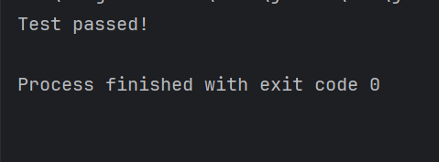

**Exercise 3: Assertions in Junit**

**3.1 Code:**

import org.junit.Test;  
import static org.junit.Assert.*;  
  
public class AssertionsTest {  
  
 @Test  
 public void testAssertions() {  
   
 *assertEquals*(5, 2 + 3);  
 *assertTrue*(5 > 3);  
 *assertFalse*(5 < 3);  
 *assertNull*(null);  
  
   
 *assertNotNull*(new Object());  
 }  
}

**3.2 Output:**

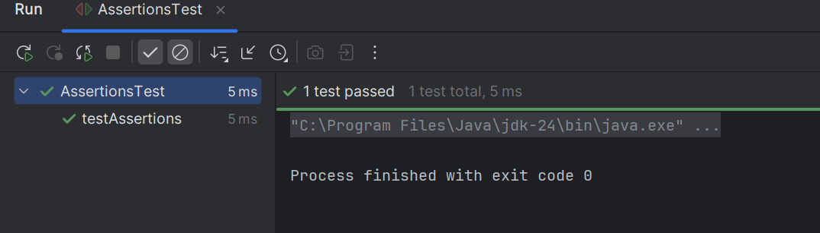

**Exercise 4: Arrange-Act-Assert (AAA) Pattern, Test Fixtures, Setup and Teardown Methods in JUnit**

**4.1 Code:**

import org.junit.Before;  
import org.junit.After;  
import org.junit.Test;  
import static org.junit.Assert.*;  
  
  
class BankAccount {  
 private double balance;  
  
 public BankAccount(double initialBalance) {  
 this.balance = initialBalance;  
 }  
  
 public void deposit(double amount) {  
 if (amount > 0) balance += amount;  
 }  
  
 public void withdraw(double amount) {  
 if (amount > 0 && amount <= balance) balance -= amount;  
 }  
  
 public double getBalance() {  
 return balance;  
 }  
}  
  
  
public class BankAccountTest {  
  
 private BankAccount account;  
  
 @Before  
 public void setUp() {  
 account = new BankAccount(100.0);  
 System.*out*.println("Setup: New account created with balance 100.0");  
 }  
  
 @After  
 public void tearDown() {  
 System.*out*.println("Teardown: Test completed.");  
 }  
  
 @Test  
 public void testDeposit() {  
   
 double depositAmount = 50.0;  
  
   
 account.deposit(depositAmount);  
  
   
 *assertEquals*(150.0, account.getBalance(), 0.001);  
 }  
  
 @Test  
 public void testWithdraw() {  
   
 double withdrawAmount = 30.0;  
  
   
 account.withdraw(withdrawAmount);  
  
   
 *assertEquals*(70.0, account.getBalance(), 0.001);  
 }  
}

**4.2 Output:**

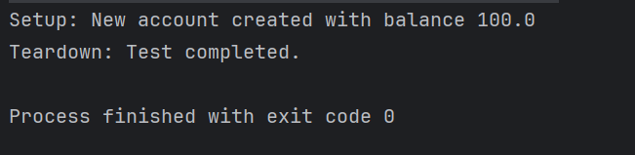

**2. Mockito:**

**Exercise 1: Mocking and Stubbing**

* 1. **Code:**

**‘pom.xml’ file:**

<project xmlns="http://maven.apache.org/POM/4.0.0"  
 xmlns:xsi="http://www.w3.org/2001/XMLSchema-instance"  
 xsi:schemaLocation="http://maven.apache.org/POM/4.0.0  
 http://maven.apache.org/xsd/maven-4.0.0.xsd">  
  
 <modelVersion>4.0.0</modelVersion>  
  
 <groupId>org.demo</groupId>  
 <artifactId>ApiMockTestApp</artifactId>  
 <version>1.0-SNAPSHOT</version>  
  
 <properties>  
 <maven.compiler.source>1.8</maven.compiler.source>  
 <maven.compiler.target>1.8</maven.compiler.target>  
 <project.build.sourceEncoding>UTF-8</project.build.sourceEncoding>  
 </properties>  
  
 <dependencies>  
   
 <dependency>  
 <groupId>org.junit.jupiter</groupId>  
 <artifactId>junit-jupiter</artifactId>  
 <version>5.9.1</version>  
 <scope>test</scope>  
 </dependency>  
  
 <dependency>  
 <groupId>org.mockito</groupId>  
 <artifactId>mockito-core</artifactId>  
 <version>4.8.0</version>  
 <scope>test</scope>  
 </dependency>  
 </dependencies>  
  
 <build>  
 <plugins>  
 <plugin>  
 <groupId>org.apache.maven.plugins</groupId>  
 <artifactId>maven-surefire-plugin</artifactId>  
 <version>3.0.0-M7</version>  
 </plugin>  
 </plugins>  
 </build>  
</project>

**RemoteService.java:**

package org.demo.mock;  
  
public interface RemoteService {  
 String retrieveInfo();  
}

**DataFetcher.java:**

package org.demo.mock;  
  
public class DataFetcher {  
 private final RemoteService service;  
  
 public DataFetcher(RemoteService service) {  
 this.service = service;  
 }  
  
 public String getProcessedInfo() {  
 return service.retrieveInfo();  
 }  
}

**DataFetcherTest.java:**

package org.demo.mock;  
  
import org.junit.jupiter.api.Test;  
import static org.junit.jupiter.api.Assertions.*assertEquals*;  
  
import static org.mockito.Mockito.*;  
  
public class DataFetcherTest {  
  
 @Test  
 public void testGetProcessedInfo() {  
 RemoteService mockService = *mock*(RemoteService.class);  
 *when*(mockService.retrieveInfo()).thenReturn("Mocked Response");  
  
 DataFetcher fetcher = new DataFetcher(mockService);  
 String result = fetcher.getProcessedInfo();  
  
 *assertEquals*("Mocked Response", result);  
 }  
}

* 1. **Output:**

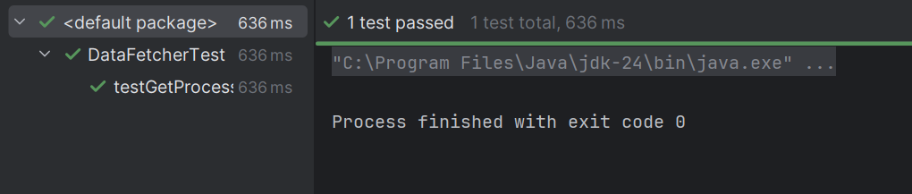

**Exercise 2: Verifying Interactions**

**2.1 Code:**

**‘pom.xml’ file:**

<project xmlns="http://maven.apache.org/POM/4.0.0"  
 xmlns:xsi="http://www.w3.org/2001/XMLSchema-instance"  
 xsi:schemaLocation="http://maven.apache.org/POM/4.0.0  
 http://maven.apache.org/xsd/maven-4.0.0.xsd">  
  
 <modelVersion>4.0.0</modelVersion>  
  
 <groupId>com.demo</groupId>  
 <artifactId>interactionVerificationTest</artifactId>  
 <version>1.0-SNAPSHOT</version>  
  
 <dependencies>  
  
 <dependency>  
 <groupId>org.junit.jupiter</groupId>  
 <artifactId>junit-jupiter</artifactId>  
 <version>5.10.0</version>  
 <scope>test</scope>  
 </dependency>  
 <dependency>  
 <groupId>org.mockito</groupId>  
 <artifactId>mockito-core</artifactId>  
 <version>5.11.0</version>  
 <scope>test</scope>  
 </dependency>  
 </dependencies>  
  
 <build>  
 <plugins>  
 <plugin>  
 <groupId>org.apache.maven.plugins</groupId>  
 <artifactId>maven-surefire-plugin</artifactId>  
 <version>3.0.0</version>  
 </plugin>  
 </plugins>  
 </build>  
</project>

**ApiService.java:**

package com.demo.verification;  
  
public interface ApiService {  
 void sendRequest();  
}

**UserService.java:**

package com.demo.verification;  
  
public class UserService {  
 private final ApiService apiService;  
  
 public UserService(ApiService apiService) {  
 this.apiService = apiService;  
 }  
  
 public void processUser() {  
 System.*out*.println("processUser() called");  
 apiService.sendRequest();   
 }  
}

**UserServiceTest.java:**

package com.demo.verification;  
  
import org.junit.jupiter.api.Test;  
import static org.mockito.Mockito.*;  
  
public class UserServiceTest {  
  
 @Test  
 public void testSendRequestCalled() {  
   
 ApiService mockService = *mock*(ApiService.class);  
   
 UserService userService = new UserService(mockService);  
   
 userService.processUser();  
   
 *verify*(mockService).sendRequest();  
 }  
}

**2.2 Output:**

